
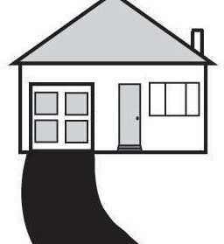
Driveways and Parking Pads
(Residential Parking Requirements)

This handout is intended only as a guide and is based in part on the 2020 Minnesota State Building Code, Isanti City ordinances, and good building practice. While every attempt has been made to ensure the correctness of this handout, no guarantees are made to its accuracy or completeness Responsibility for compliance with applicable codes and ordinances falls on the owner or contractor. For specific questions regarding ordinance & code requirements, refer to the applicable city ordinances, codes, or contact the Isanti Community Development Department.

Permits and Plans
A Zoning permit is required for any new driveway construction; extension, re-construction, alteration, or parking area. Please contact Jordyn Curtis at 763-762-5765 with any questions.
- Each application must include a Site Survey/Plot Plan showing the exact locations of the following:
  - Precise Property lines drawn neatly and to scale
  - Existing house and all impervious surfaces on property in precise dimensions to property lines
  - Proposed impervious surface location(s), materials, height; and dimensions
* Positively identifying property lines is the responsibility of the permit applicant. You may contact the Community Development Department to inquire if a copy of the property site survey is on file.

Inspections
The City of Isanti reserves the right to perform a compliance inspection when it is warranted. If you have any questions, please contact Jordyn Curtis at 763-762-5765 before proceeding.

City of Isanti General Surface Requirements
Impervious surface definition: Areas where water, air, or roots cannot readily penetrate the soil. Examples: concrete, asphalt, bituminous, paver systems at a min. 2-3/8" thick and with max. gaps of 1/4".
Improved surface definition: Areas consisting of pavers or patio block less than 2-3/8" thick and/or with gaps exceeding 1/4", or large crushed rock, gravel, or class 5 to a depth of not less than 6".
- The area covered by impervious surface must not exceed the maximum allowed within your zoning district.
- All vehicles/units with motors shall be parked or stored on an impervious surface.
- All driveways shall be an impervious surface.
- Driveways shall not be installed over any curb stops or utilities.
- Max driveway width at Right-of-Way is 30'. On cul-de-sacs: 50% of lot frontage or 30' whichever is less.
- Driveways and parking pads shall be no closer than 5' from the property line.

110 - 1st Avenue NW * Isanti, MN 55040
Phone: 763-762-5765 permits@cityofisanti.us

5.4.2026

